CZ SCORPION EVO 3 REVIEW: HANDS ON TESTING
By David Higginbotham October 1, 2023
The CZ Scorpion has been around for long enough to have a devoted cult following. The pistol version of the Scorpion (which is what I’ll be reviewing here) is by far the most popular. And in the arm-brace-era, the gun’s popularity was easy to understand. How well does it perform in the straight pistol configuration?
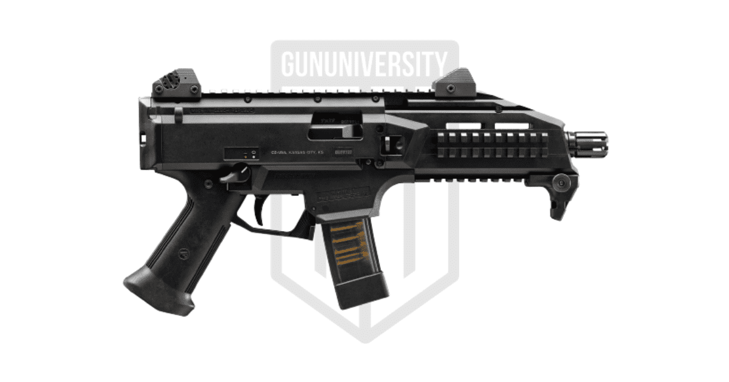

CZ Scorpion EVO 3Have an opinion on this product? Click to leave your review

CZ SCORPION EVO 3 SPECS
- Caliber9mm
- Capacity20+1
- Frame: Fibre-reinforced polymer
- Barrel: Cold hammer forged
- Barrel Length7.75 in
- Safety: Ambidextrous thumb
- Overall Length16 in
- Weight5 lbs

CZ SCORPION EVO 3 BACKGROUND
Pistol calibre carbines (PCCs) have an easily understood appeal. The shorter barrels (often found on the pistol builds) make them more manoeuvrable than some rifles. Yet the barrels on pistols like the Scorpion are usually longer than those on traditional handguns. This enables ammo like 9mm and .45 ACP to reach its full potential.
The Scorpion helped CZ gain an even larger foothold in the US. It proved to be a very robust design—large enough to add on just about any accessory you wanted, but not so huge as to be even remotely cumbersome.
The Scorpion draws its inspiration from a long line of submachine guns—putting the action forward of the grip. The magazine well acts as a decent hand-stop.
CZ made a true sub-gun variant of the Scorpion EVO 3, a gun only sold in military and LE channels. If you want a stock, there’s a version with a folding stock—but it has a much longer barrel on it. They do this to meet the OAL length requirements needed to keep it categorized as a rifle.
While the carbine is a fine place to start an SBR build, most of us gravitate to the shorted pistol configurations. As a pistol, if you’ll allow this statement of the obvious, it is much less stable than it is in the carbine version. Having a stock is a real benefit. Yet the extra length is a factor, so which is more important?

CZ Scorpion EVO 3 Features
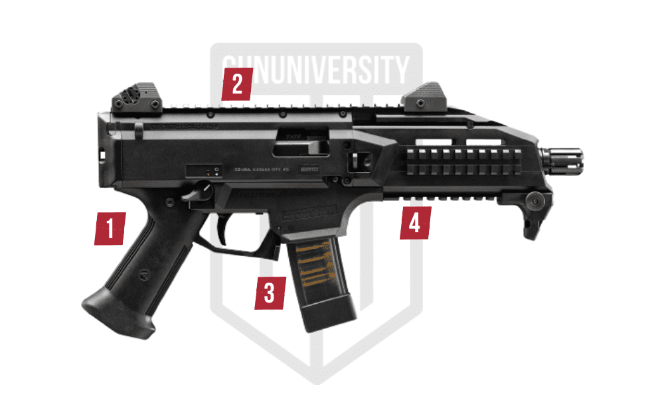

1PISTOL GRIP
Integrated pistol grip. The firing hand ergonomics are solid.

2COMPACT DESIGN
The size makes this easy to manoeuvre in tight spaces, while not being too compact and not having enough gun to hold onto for control.

3STICK MAGAZINE
Detachable stick magazines. 9mm is cheap, plentiful, and effective.

4RAIL SPACE
The Scorpion has a lot of rail space so it is very easy to add on to for both the top rail for optics and around the fore end for other accessories.

MODELS AND VARIATIONS
The CZ Scorpion has been upgraded recently. Here is the pistol and carbine variants of the new CZ Scorpion 3+.

CZ Scorpion 3+ Carbine
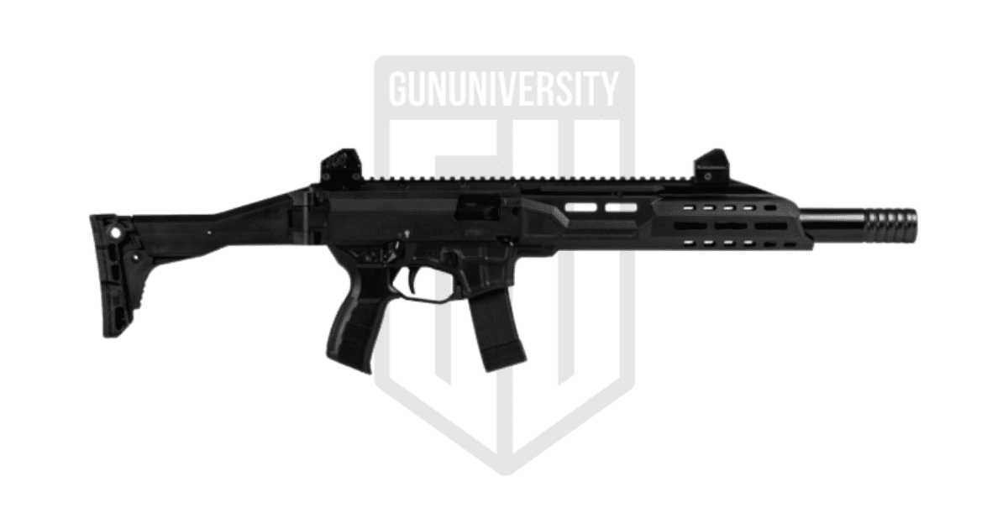

CZ Scorpion 3+ Pistol
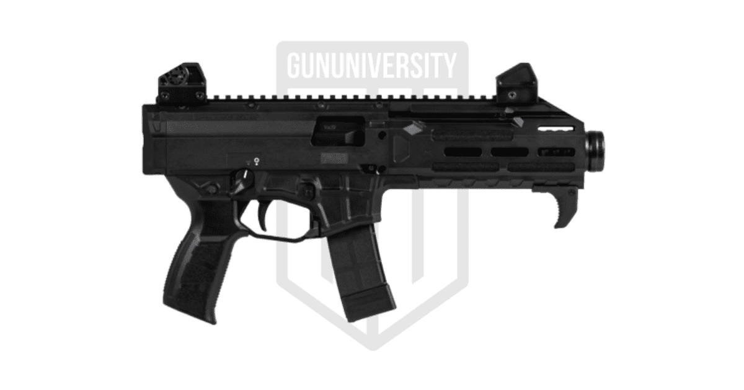

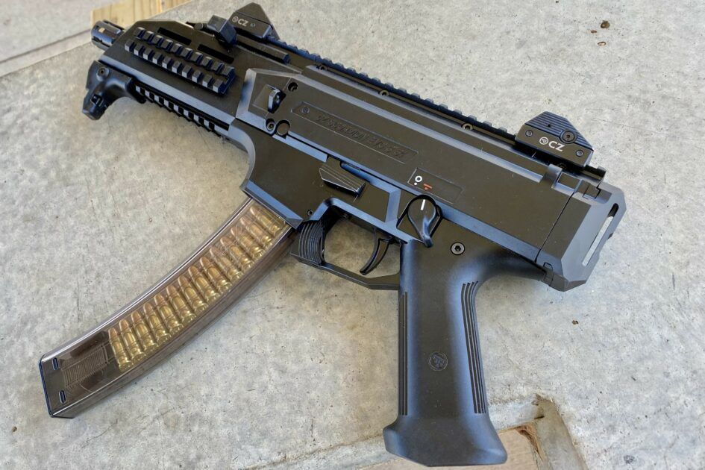
This is my second Scorpion, and the first that I’ve run without the benefit of a pistol brace. While it doesn’t influence the way the Scorpion shoots, I’d be lying if I said I don’t miss the brace.
One of my favourite things about this gun is its speed. At just over 5 pounds, it is easy to use while moving. There’s almost no recoil. The inherent stability and weight make it a natural choice for engaging multiple targets.
Without the brace attached, and in this pistol configuration, I’m finding it dips slightly between shots. In previous reviews, I compared suppressed pistols to dolphins due to the unique recoil and forward weight that gives them a swimming feel. The Scorpion, similarly, may feel different without a stock or brace to anchor the back end.
But the thing shoots lights out. It is easy to point, and light enough that you can even shoot it one handed if you had to.

DOES THE SCORPION FAIL?
As a blowback operated 9mm, the reliability is inherently tied to the ammunition you feed it. I’ve run heavy sub-sonic Aguila through it with no issues in performance. Defensive rounds like Horney’s Critical Duty feel snappy but run just as well. Bulk 115 grain runs great.
I’ve yet to have an actual failure with the Scorpion, so no complaints there. I do train regularly—and I like to force failures with dummy rounds and empty cases. There’s a learning curve here that will require dropping the mag and racking the slide, which isn’t as easy as it is on most handguns.
While I’ve yet to have a case get lodged in the chamber, this would be hell to get clear in any kind of fast and efficient fashion. Rather than attempting to reach in, I’d highly suggest running the slide violently and allowing the extractor to do what it does best.
Even with steel-cased ammo, though, I’ve never had a round stick. Ejection is forceful and reliable.

ERGONOMICS
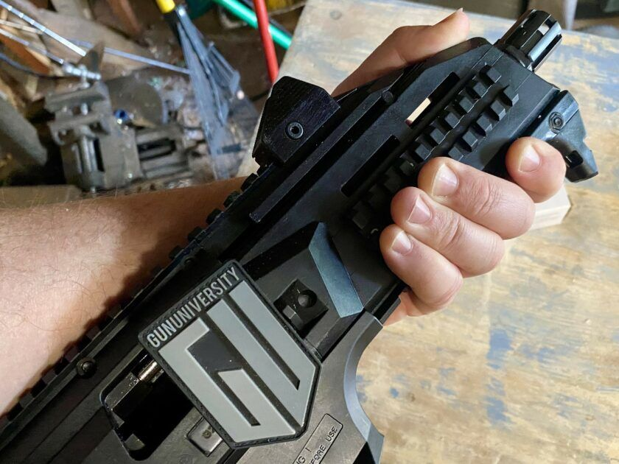
I’m not small. As PCCs go, this is on the smaller side. Or maybe shorter is a better way to describe it. Unlike some of the long-thin PCCs with stocks, this one is very compact.
The Scorpion isn’t small, though. They built the frame out of polymer and it is really robust. It fills the hand completely and can be challenging to hold for those who are used to the thin tubular rails that are common on ARs. There is ample rail space for adding a forward grip, depending on the legalities of your situation and current ATF rules.

ERGONOMICS REDUX
While we’re on the topic of the SBR…. Up until the most recent rulings on pistol braces, very few Scorpion pistols were left naked. Adding a brace really made the platform shine.
But politics got in the way. Now you can get a carbine version or a pistol version. Shooting the pistol without a brace may be cumbersome for some—but there are options.
Adding a strap is a natural way to add some control. Not only will you get a convenient way to carry the Scorpion, but you can use the strap as an anchor to push out against the gun. This sounds odd, but forcing the gun away and allowing the strap to tighten against your shoulder will keep the back end from bouncing.
I don’t think about driving larger guns away the way I do handguns, but it has the same effect. Again, you may have to break some bad habits—like pulling a PCC or rifle into your shoulder—but the practice is worthwhile. Drive to the target and watch how accurate your first shot becomes.
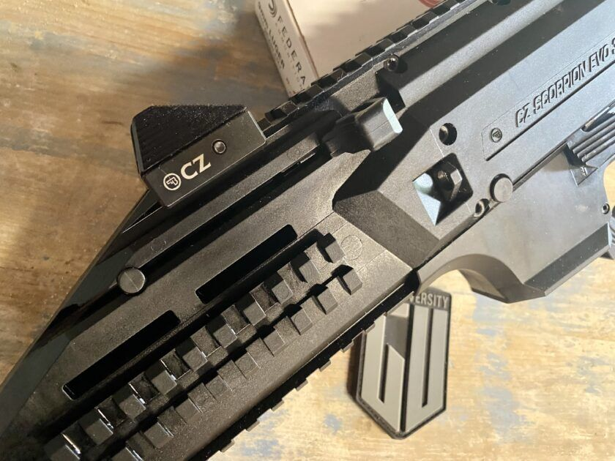
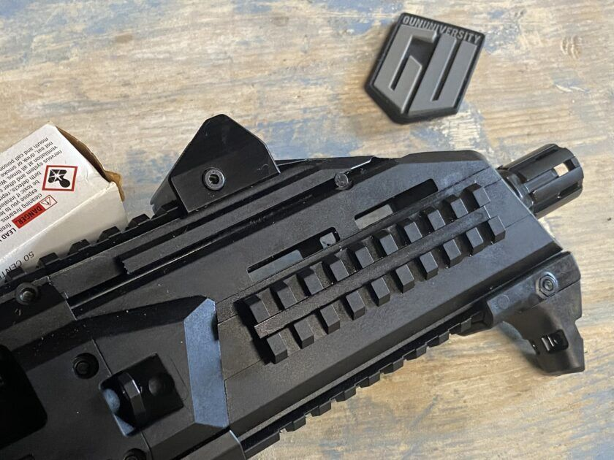

ACCURACY
Accuracy is everything, right? Not always. The Scorpion isn’t a MOA gun—not in its pistol configuration (and not when it’s fired under typical conditions).
As this is a PCC, my expectation for performance change. I want effective shot placement. Accuracy—gnat’s ass type of accuracy—is icing on the cake. Effective shot placement and getting rounds on target fast is what matters most to me.
And that’s where the Scorpion excels. At 25 yards and under, this gun runs exceptionally well. Even as a pistol (as opposed to the carbine), the Scorpion points effectively.
I like the sights. No complaints there. This is, though, the ideal platform for a larger red dot. While many are enamoured with tiny red dots, I like those with a larger field of view on a gun like this. Even an optic as chunky as an old EOTech won’t look out of place on top of the Scorpion.

VALUE
The Scorpion’s price tag is on par with what you can expect for AR styled PCCs. While some American brands have PCC designs that do similar things, they price the Scorpion a bit higher—yet still under $900.
For an effective platform, though, that is adaptable, compact, reliable, and easy to set up to your exact needs, the gun is worth it.
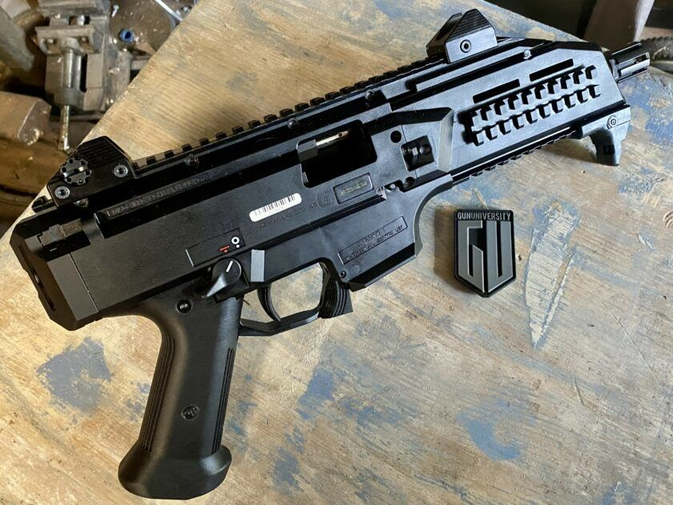

CZ SCORPION EVO 3 PROS AND CONS
- Compact Design – Its not too big and not too small, Goldilocks zone.
- Magazines – Excellent mags available
- Rail Space – Lots of rail space to add the accessories and optics you need.
- “Pistol” – Benefits from a brace or stock.
- Customization – Not as easy to customize as some PCC platforms.

REPORT CARD
SHOOTABILITY | The Scorpion shoots incredibly well, but—as noted—would be more stable with a stock. | B
RELIABILITY | I had no issues with this Scorpion or any of the others I’ve worked with. The platform runs flawlessly. | A+
ERGONOMICS | I can’t hold CZ responsible for the arm brace debacle. Otherwise, this gun is easy to control and hold. The fore end is large—by design, of course—but that is the only place where I feel like making a change. | A-
ACCURACY | First shot accuracy is easy to accomplish. Follow up shots from the big pistol are less likely to form solid groups, but that’s hardly the point. They’ll connect with the target. | B
VALUE | There are PCCs that will sling lead for less. There are also many more that will cost twice or three times what you’d pay for a Scorpion. Or more. | B
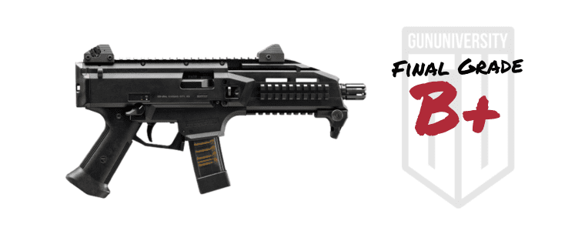

CZ Scorpion EVO 3

